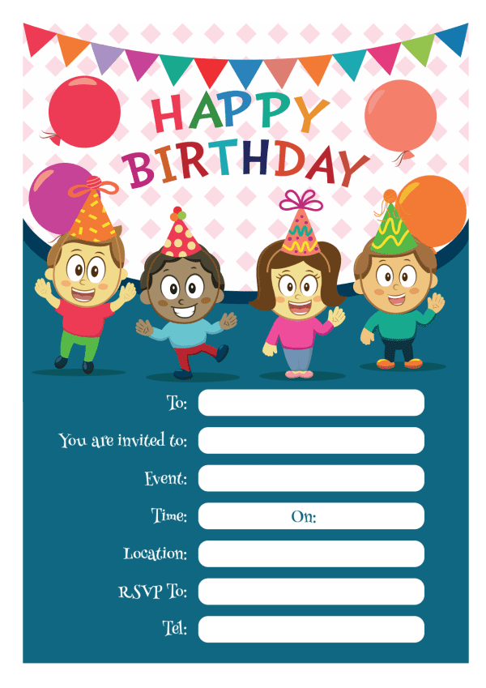
Provided by
King of the castles entertainments 07968633946
Provided by
King of the castles entertainments 07968633946

