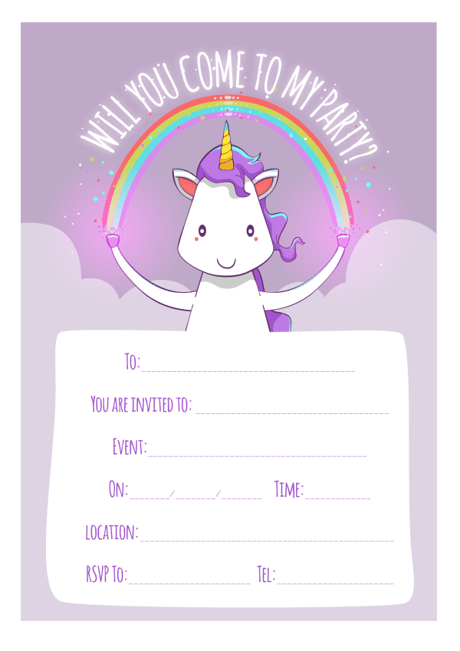
Provided by
King of The Castles Entertainments 07968633946
Provided by
King of The Castles Entertainments 07968633946

