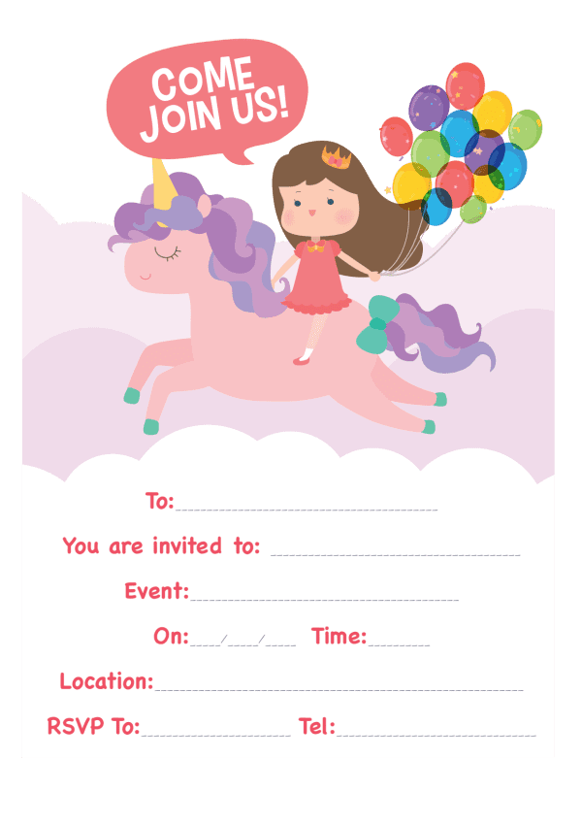
Provided by
King of the Castles Entertainments 07968633946
Provided by
King of the Castles Entertainments 07968633946

