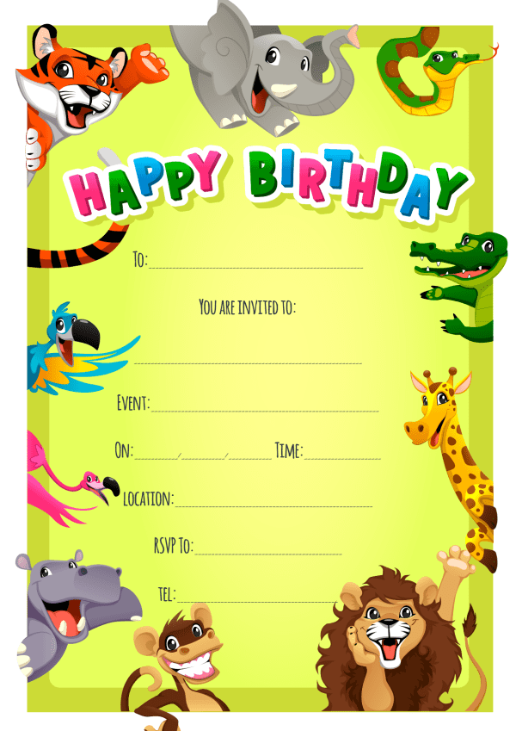
Provided by
King of the Castles Entertainments 07968633946

Provided by
King of the Castles Entertainments 07968633946

